IEVA DUDAITE
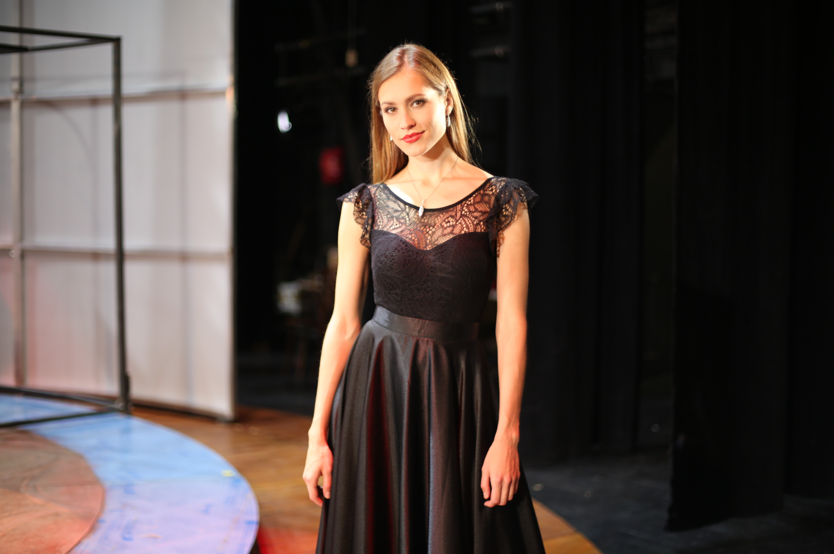

Ieva Dudaite, one of the most promising Lithuanian pianists of her generation, has a lengthy record of concerts across the globe.
She has delighted the public with many recitals in Lithuania (Vilnius and Kaunas Philharmonic), the Netherlands (Concertgebouw Amsterdam, Theater aan het Vrijthof Maastricht, Muziekgebouw Eindhoven, TivoliVredenburg Utrecht), Belgium (DeSingel Antwerp), Italy, Germany, Mexico, the USA, the United Kingdom, France, Spain, Romania, Albania, the Czech Republic, Ukraine, Gibraltar and Estonia to mention but a few.
Her talents have been enjoyed at renowned music festivals, including Grenoble Music Festival 2008, Trieste Music Festival 2010, Aurora Chamber Music Festival Sweden 2015 and Oxford Piano Festival 2016. Several of Dudaite’s concerts have been recorded and broadcasted by Lithuanian, Russian, and Dutch Radio and Television.
She has accompanied such world-class artists as Pacho Flores, Sergei Nakariakov and Ruben Simeo.
Born in Lithuania she is the winner of several 1st prizes and Grand Prix at international competitions, such as, International Young Accompanist Competition in Vilnius 2010, “Concorso di Interpretazione musicale di

Genova 2007 and 2008” in Italy. Ieva has been the finalist of the Yamaha Foundation Scholarship Competition 2014 and Grachtenconcours Amsterdam 2015, and most recently appeared at the prestigious ARD International Music Competition in Munich. She has consequently been awarded diplomas and honourable mentions from the Lithuanian presidents Valdas Adamkus and Dalia Grybauskaite as well as the Lithuanian government for her outstanding musical achievements.

The pianist has taken masterclasses with Menahem Pressler, Paul Badura-Skoda, Marianna Shirinyan, Peter Donohoe, Alexander Melnikov, Valentina Berman and Till Fellner. She has worked with several conductors, including Hobart Earle (Odessa Philharmonic Orchestra), Arjan Tien (Maastricht Conservatorium Symphony Orchestra), and Alexandros Kavvadas (Maastricht Chamber Orchestra).
Dudaite’s education in the musical sphere was likewise shaped by her teachers Igor Cognolato (Conservatorium Giuseppe Tartini in Trieste) and Jeroen Riemsdijk (Conservatorium Maastricht), with whom she has graduated her Piano Bachelor. She has recently graduated from her Piano Master with Prof. Kalle Randalu at the Hochschule fur Musik Karlsruhe, Germany.
Chamber music plays a very significant role in her repertoire. In the winter of 2010, Ieva formed a Piano Trio GIL, which performed together with the Borodin String Quartet in the Museum aan Het Vrijthof in May 2013.
Ieva Dudaite’s wide-ranging repertoire extends from the baroque epoch up until the music of the 21st century. One of her special motivations is the popularization of the Lithuanian repertory, including composers like M. K. Ciurlionis, V. Barkauskas and V. Bartulis. Dutch composer Wim Zwaag and Lithuanian composer Jurgis Kubilius have composed sonatas for her. Ieva has played the grand piano Beschstein (1975) on loan from the Nationaal Muziekinstrumenten Fonds (NMF) Amsterdam.

The highlights of the 2019/20 season include her tour across her native Lithuania with the original program “Amelie meets Chopin”, and the release of her debut album “Tiersen meets Chopin” October 4, 2019 with the label ARS Produktion.
Ieva has a marked gift for languages. She speaks a total of eight languages fluently, including music.

